Finding a spot for a Vegan/Vegetarian restaurant in Toronto

A. Introduction

A.1. Description & Disscusion of the Background

Our customer plans to open a chain of Vegan/Vegetarian Restaurants - The Veg-fo-tot (defining a catchy name is not part of this project). Most probable location to start is Toronto. As veganism/vegetarianism is becoming more and more popular there might be places in the city where such venues already exist. There are two findings of this analysis that we want to get:

1. The best locations to set up the first restaurant.

2. Based on the number of similar locations we find to decide if to open additional places or to focus on the first one only.

A.2. Data Description

We will use the following data:

1. Foursquare to find the already existing vegetarian/vegan restaurants.

2. Toronto City's open data Neighborhood profiles to retrieve the income data - Vegan food is not cheap so we need to find out neighborhoods which will be able to afford it. https://portal0.cf.opendata.inter.sandbox-toronto.ca/dataset/neighbourhood-profiles/

2a. We will use the above dataset to additionally retrieve data about population, commuting time, and education of the citizens. The dataset contains hundreds of columns with different data that is why it was necessary to process it deeply.

3. Toronto Police Safety Data Portal to retrieve data about criminality in different neighborhoods - Vegan hipsters might be very uneasy about the surroundings so the atmosphere around our restaurants must be safe. http://data.torontopolice.on.ca/datasets/neighbourhood-crime-rates-boundary-file-

4. To retrieve needed geodata and postalcodes for are master file I have used Wikipedia: https://en.wikipedia.org/wiki/List_of_postal_codes_of_Canada
and again Toronto City’s open data service: https://ckan0.cf.opendata.inter.sandbox-toronto.ca/download_resource/1d02b0f0-d735-4469-8f71-ea6d96b319e4?format=geojson&projection=4326

B. Methodology
As the first thing after downloading all datasets do I needed to choose the most interesting categories and clean up the data.
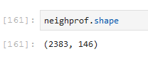
The main dataset –neighprof, was a massive structure of 2383 rows and 146 columns. This dataset contains a lot of the infomration about Toronto’s neighbourhoods.

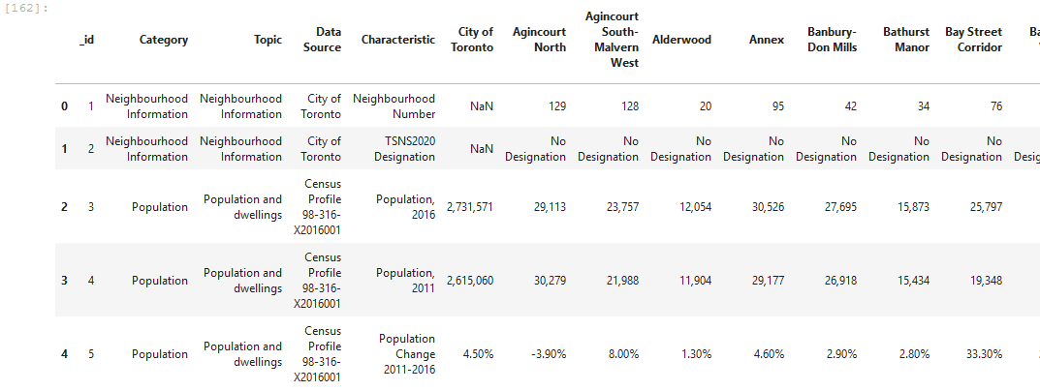
After a series of changes to dataset counted 140 rows and 15 columns:
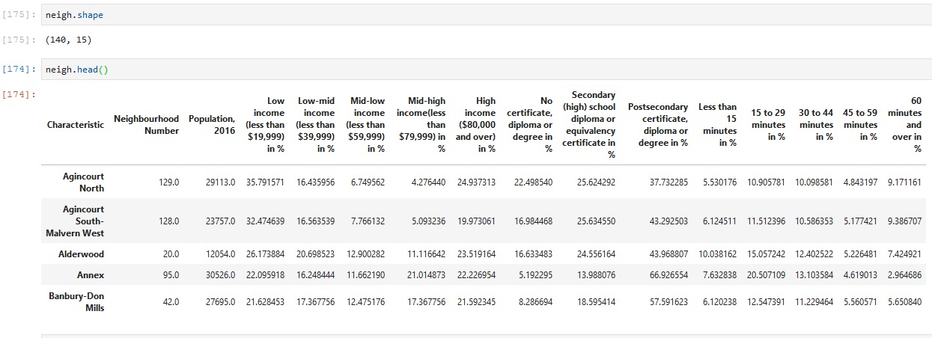
From all the categories the most interesting were those related to the population number, income, education and commuting time.
The selected categories were formatted to display their value as a percentage of population in a specific Neighborhood.
An another interesting category (criminality) was not available in the neighprof dataset hence it was necessary to extract it from a different one – crimestats.
This dataset was much smaller and friendly:
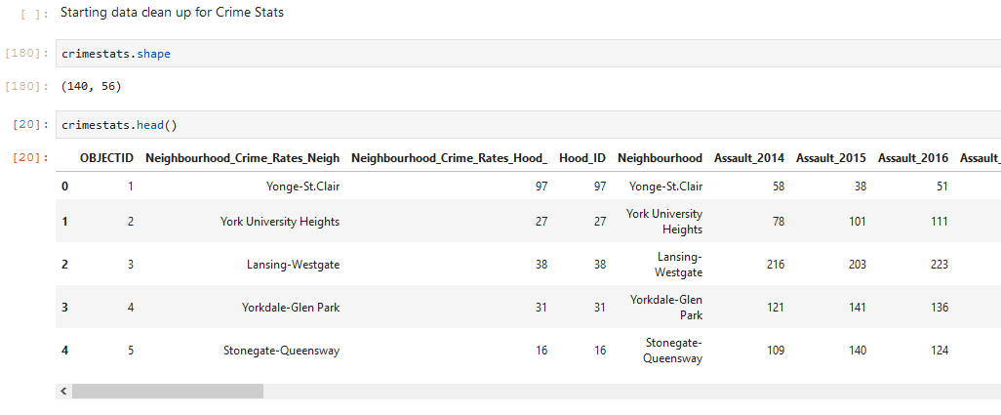
After data formatting only one category was left – Total Crime per pop representing combined number of crimes in 2018 for specific neighbourhood. In the next steps it was also divided by the number of pop in each neighb.
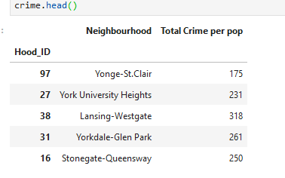
Both datasets were joined together:
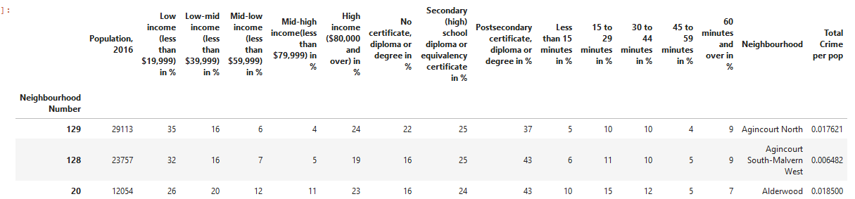
I have used Foursquare to retrieve vegetarian/vegan venues from the city. I did not set any limits and requested the information from the whole area of the city.
Initially the result was 20+ venues, but after additional filtering and matching their postcodes with neighborhood’s names the final list contained 17 spots:
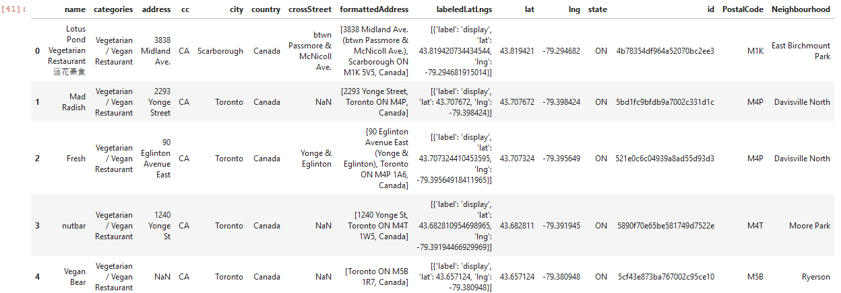
I have visualized them together with all the neighborhoods using folium library on the map of Toronto:
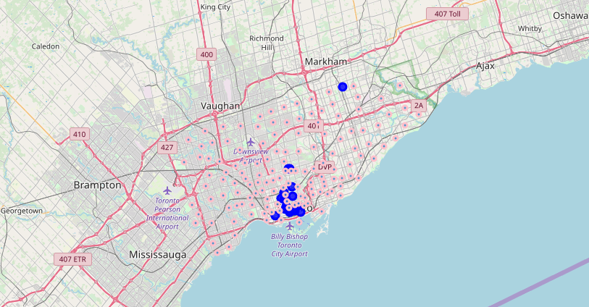
Later I have combined the number of venues for each neighborhood with the main table creating two new columns:
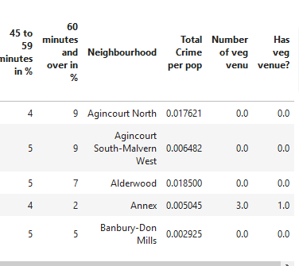
With this data I have used the K-means algorithm to cluster similar neighborhoods in 3 groups: 0-Bad Spot, 1-OKSpot, 2-GoodSpot:
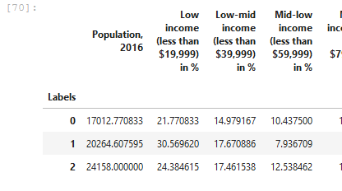
Below version with the naming adopted:
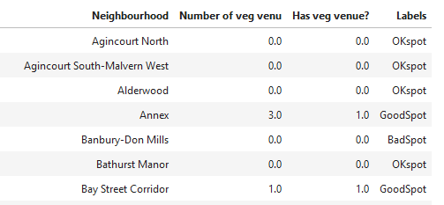

Later on I have used the choropleth map to visualize the results.

C. Results
After grouping the results we have found that 61 out of 139 neighborhoods would be worth to be treated as a potential place for a new vegetarian/vegan restaurant with 13 GoodSpot and 48 OKspot results.

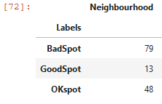
Here is how it looks on the map of Toronto.

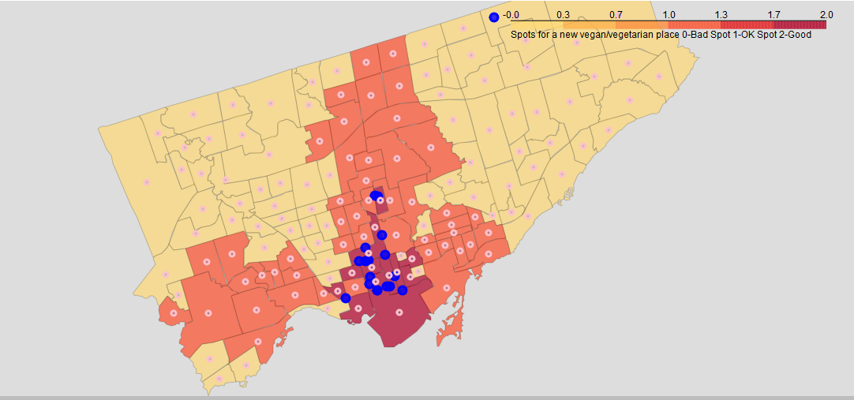

D. Discussion
As already presented in the data above, Toronto has a very limited number of vegetarian/vegan venues numbering around 20 spots with most of them located more or less in the center of the city. Some of the neighborhoods in the top category already have vegetarian/vegan venues. Question which may arise is – should these neighborhoods be there?
The answer is – yes. As the choice of this kind of venues in the city is limited it should not affect the decision of treating the neighborhood as attractive. These places one of those in which our potential customers would look either for a vegetarian/vegan restaurant or a place to eat in general.

F. Conclusion
Toronto is still a place where competition on the vegetarian/vegan restaurants market is not high so with a good location and an idea for a good menu it could be a promising place for starting this kind of business.

